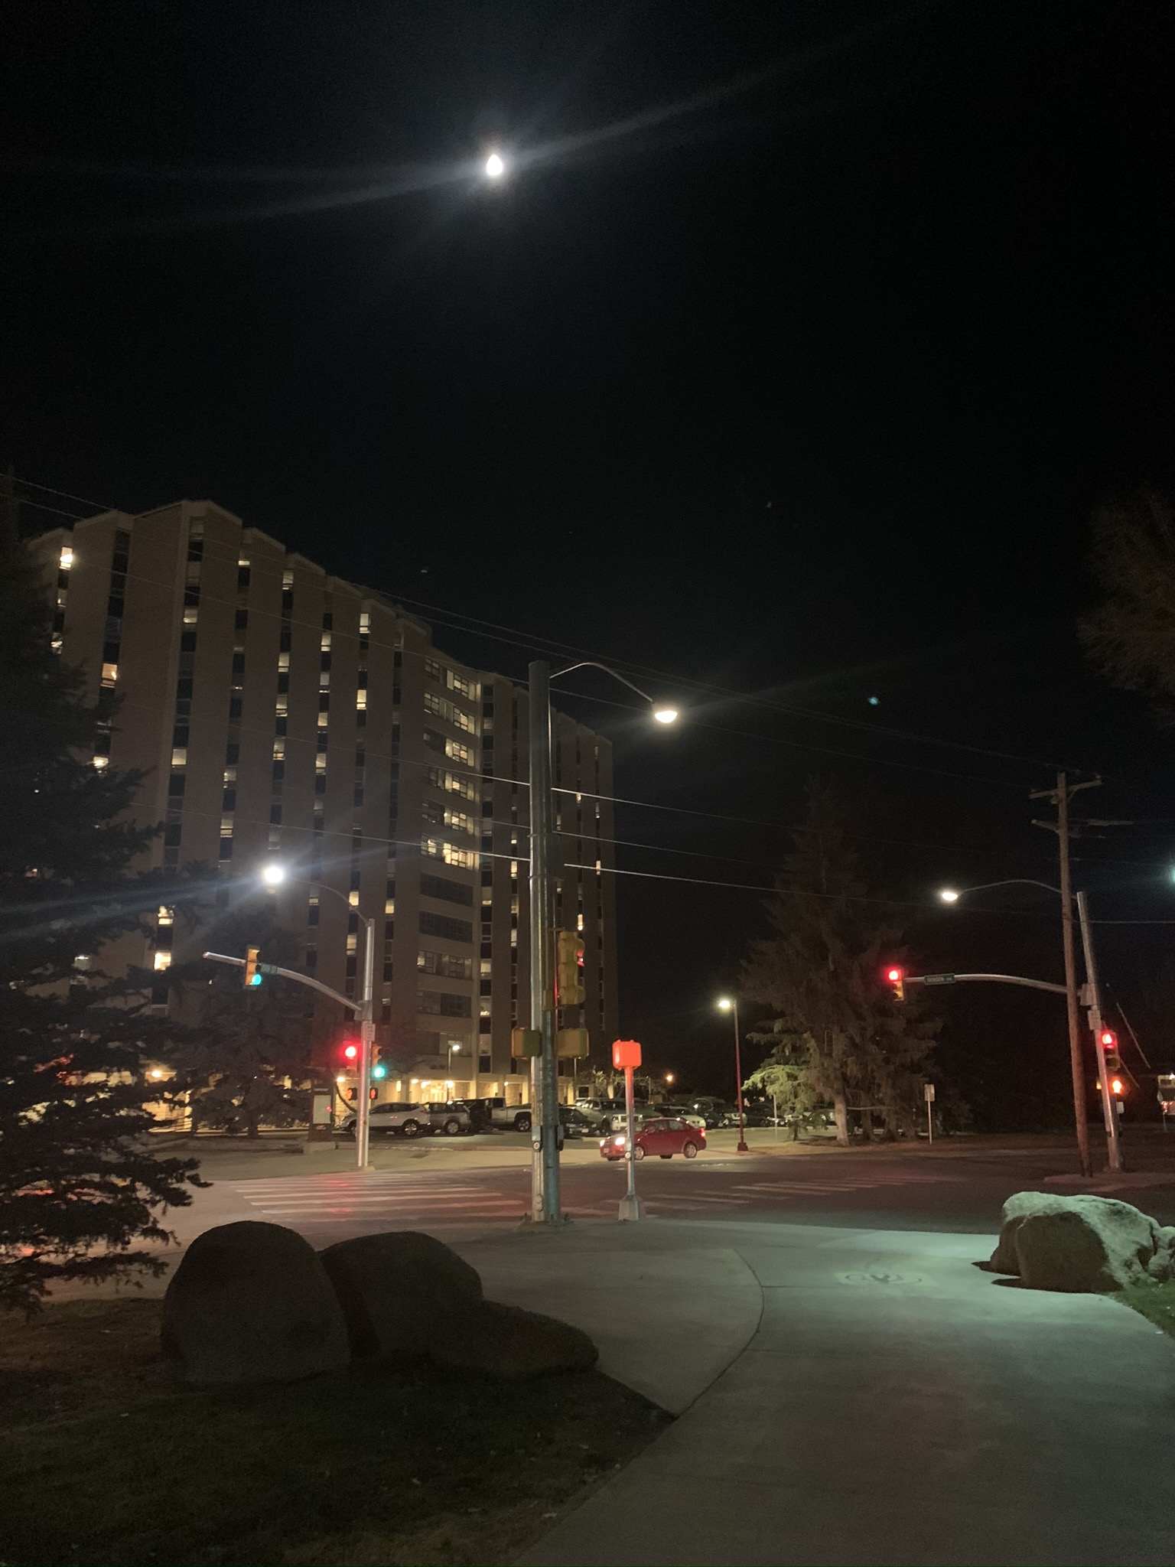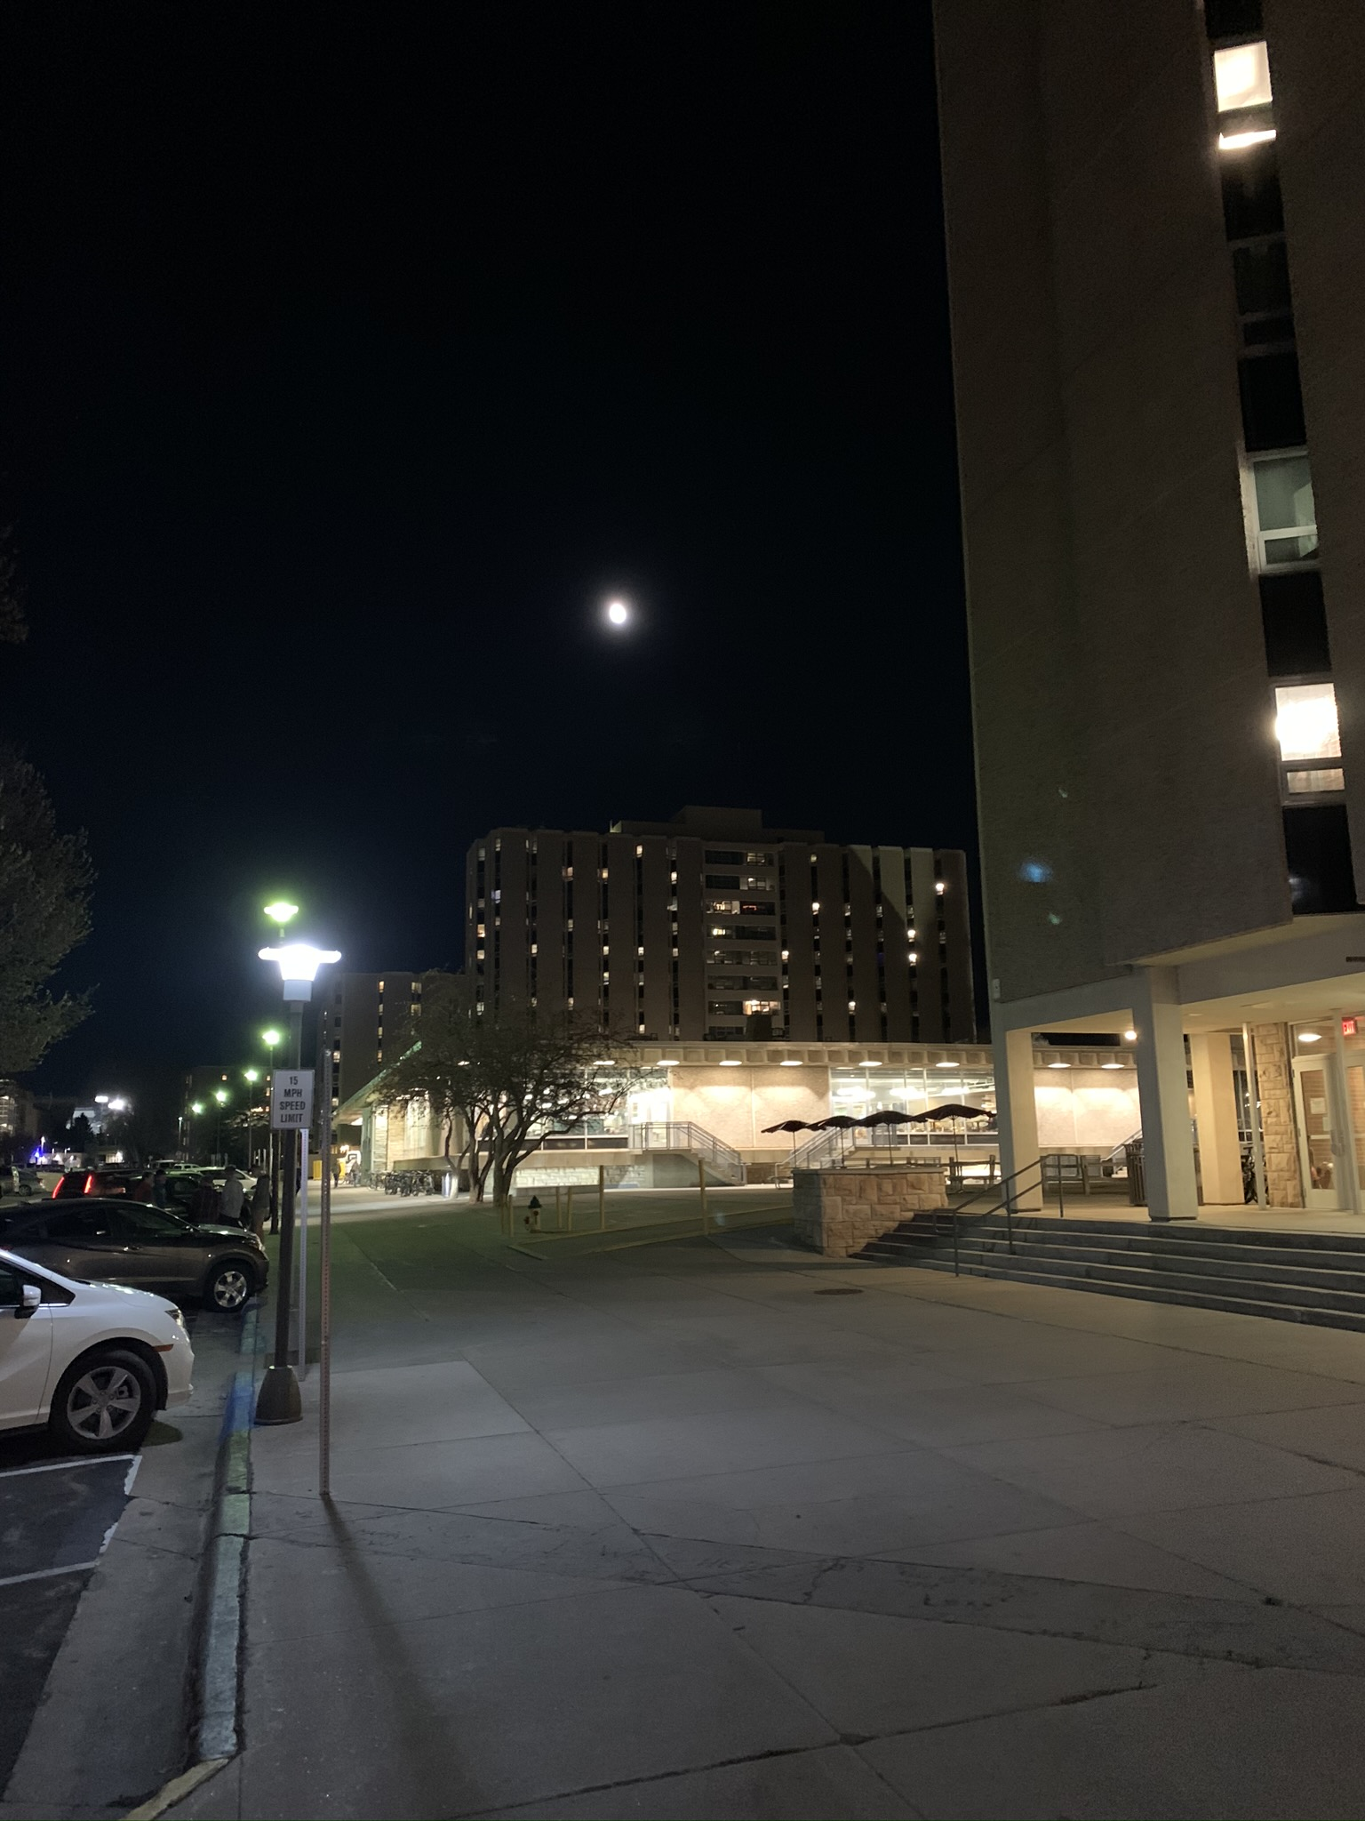 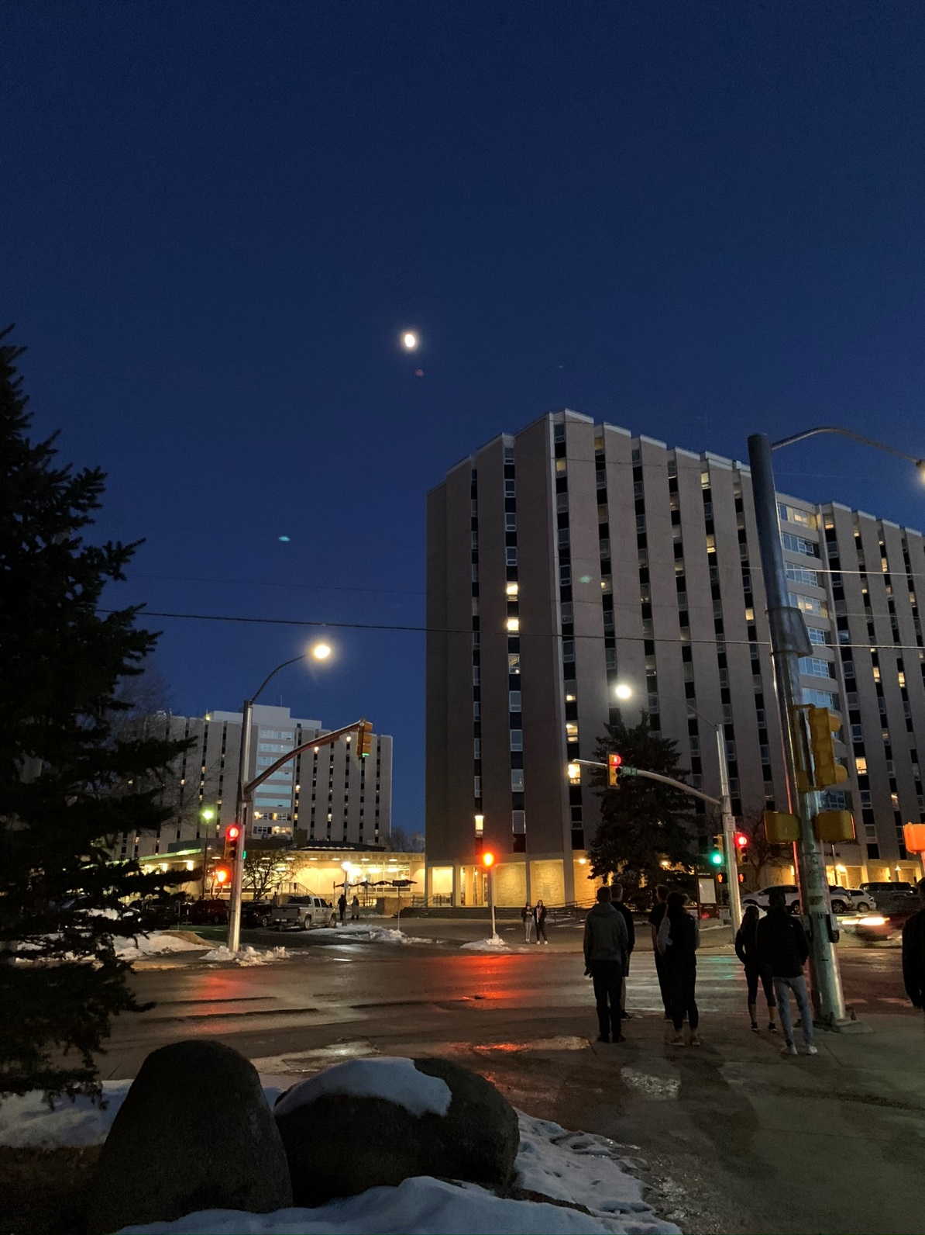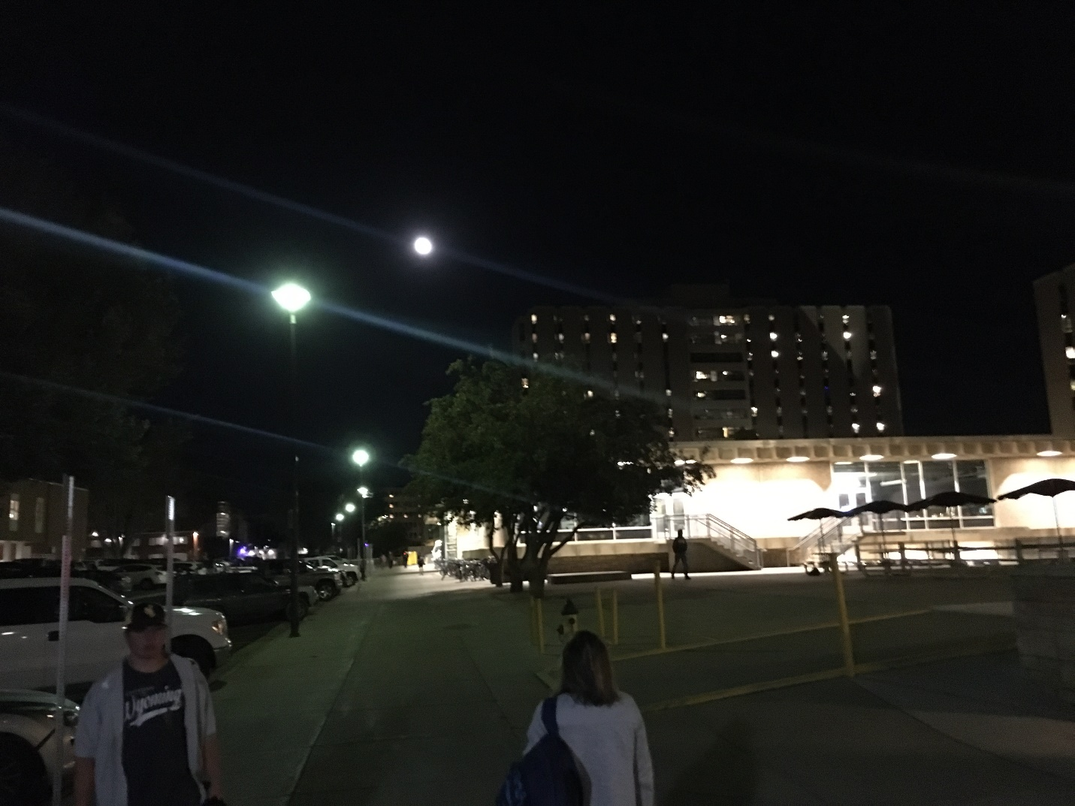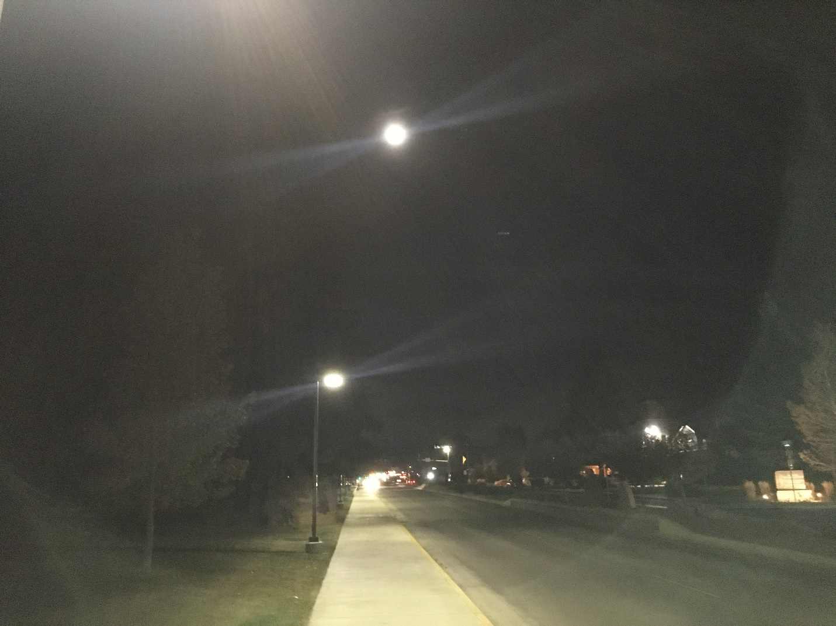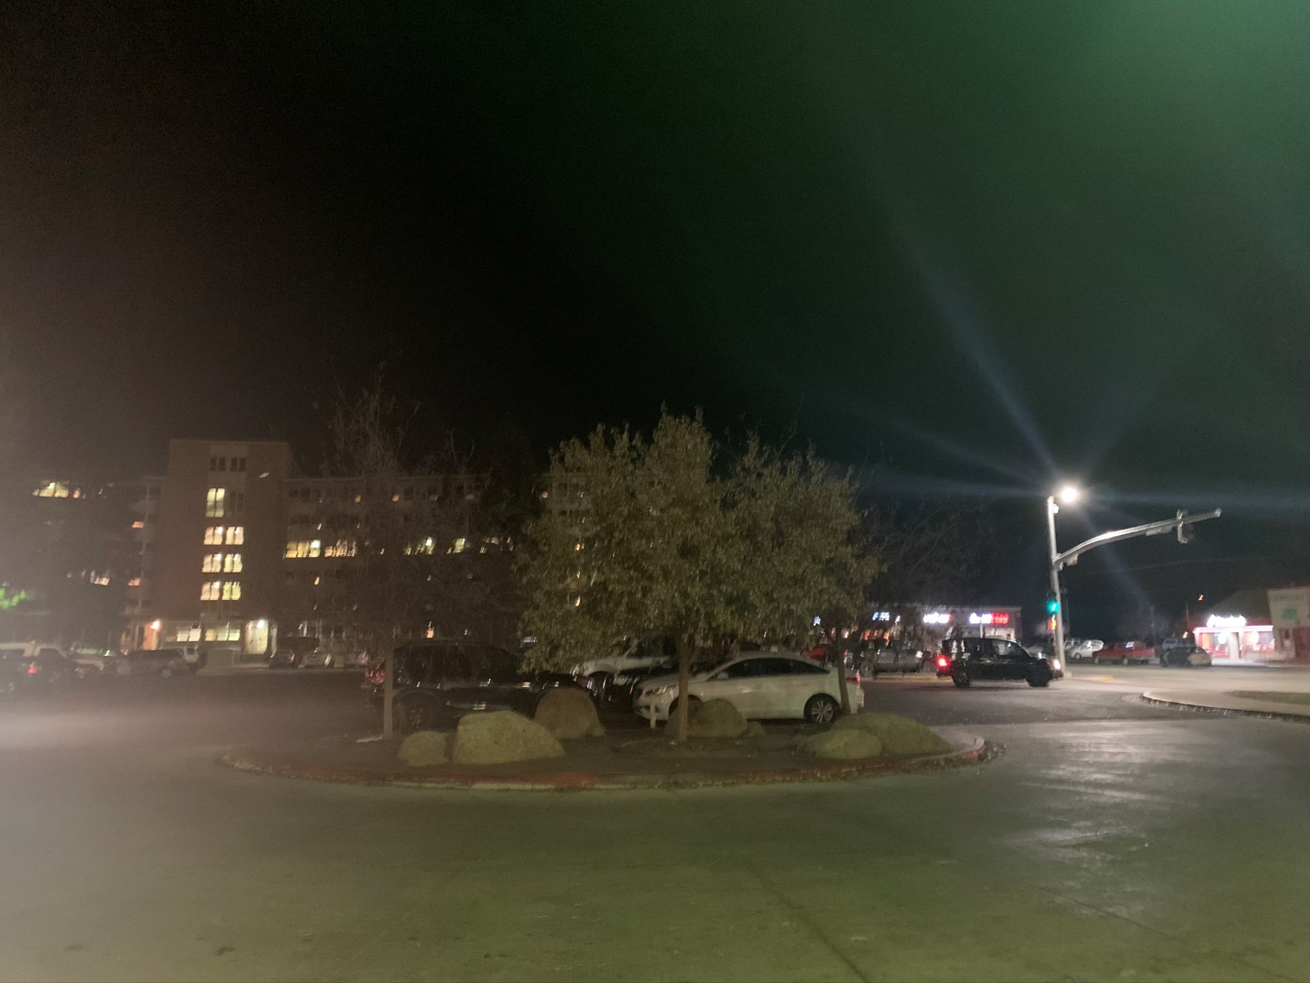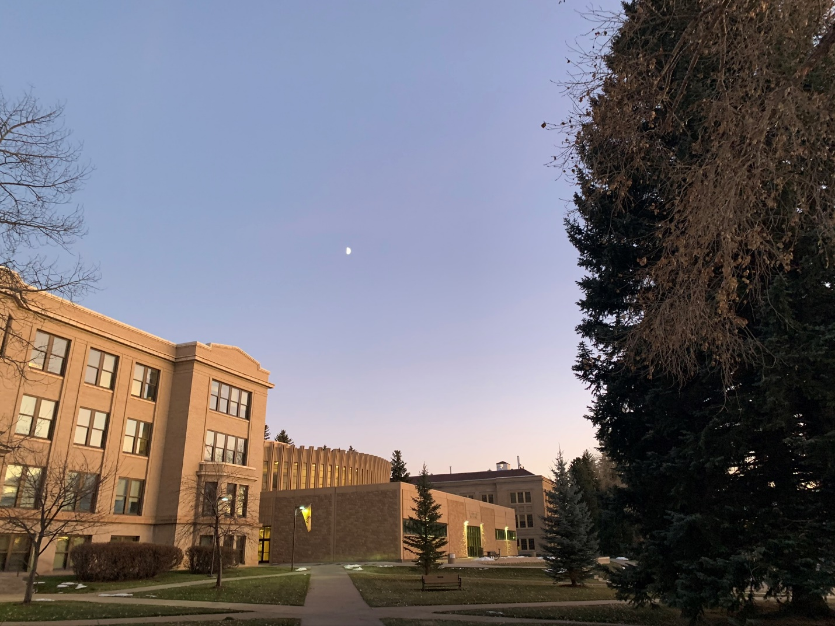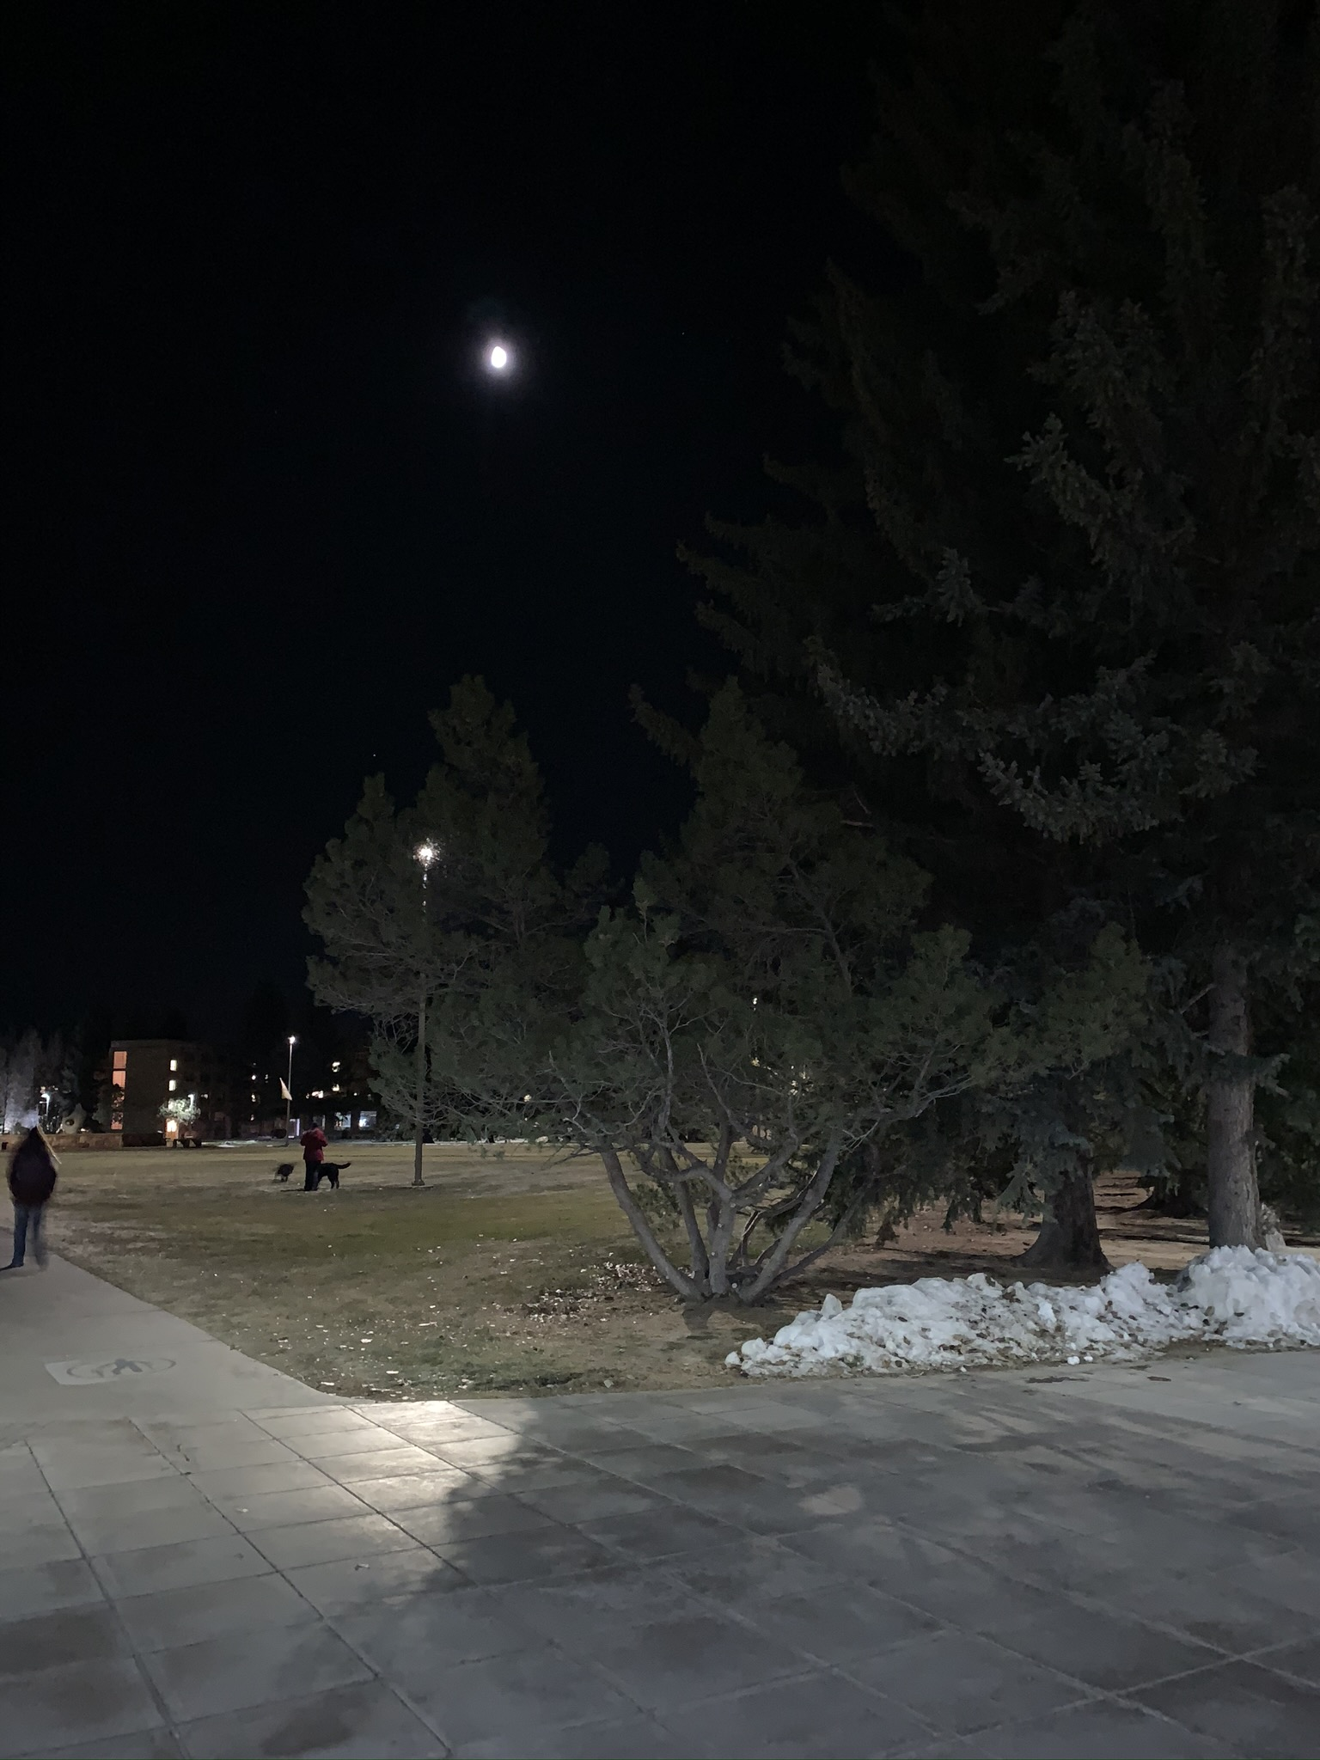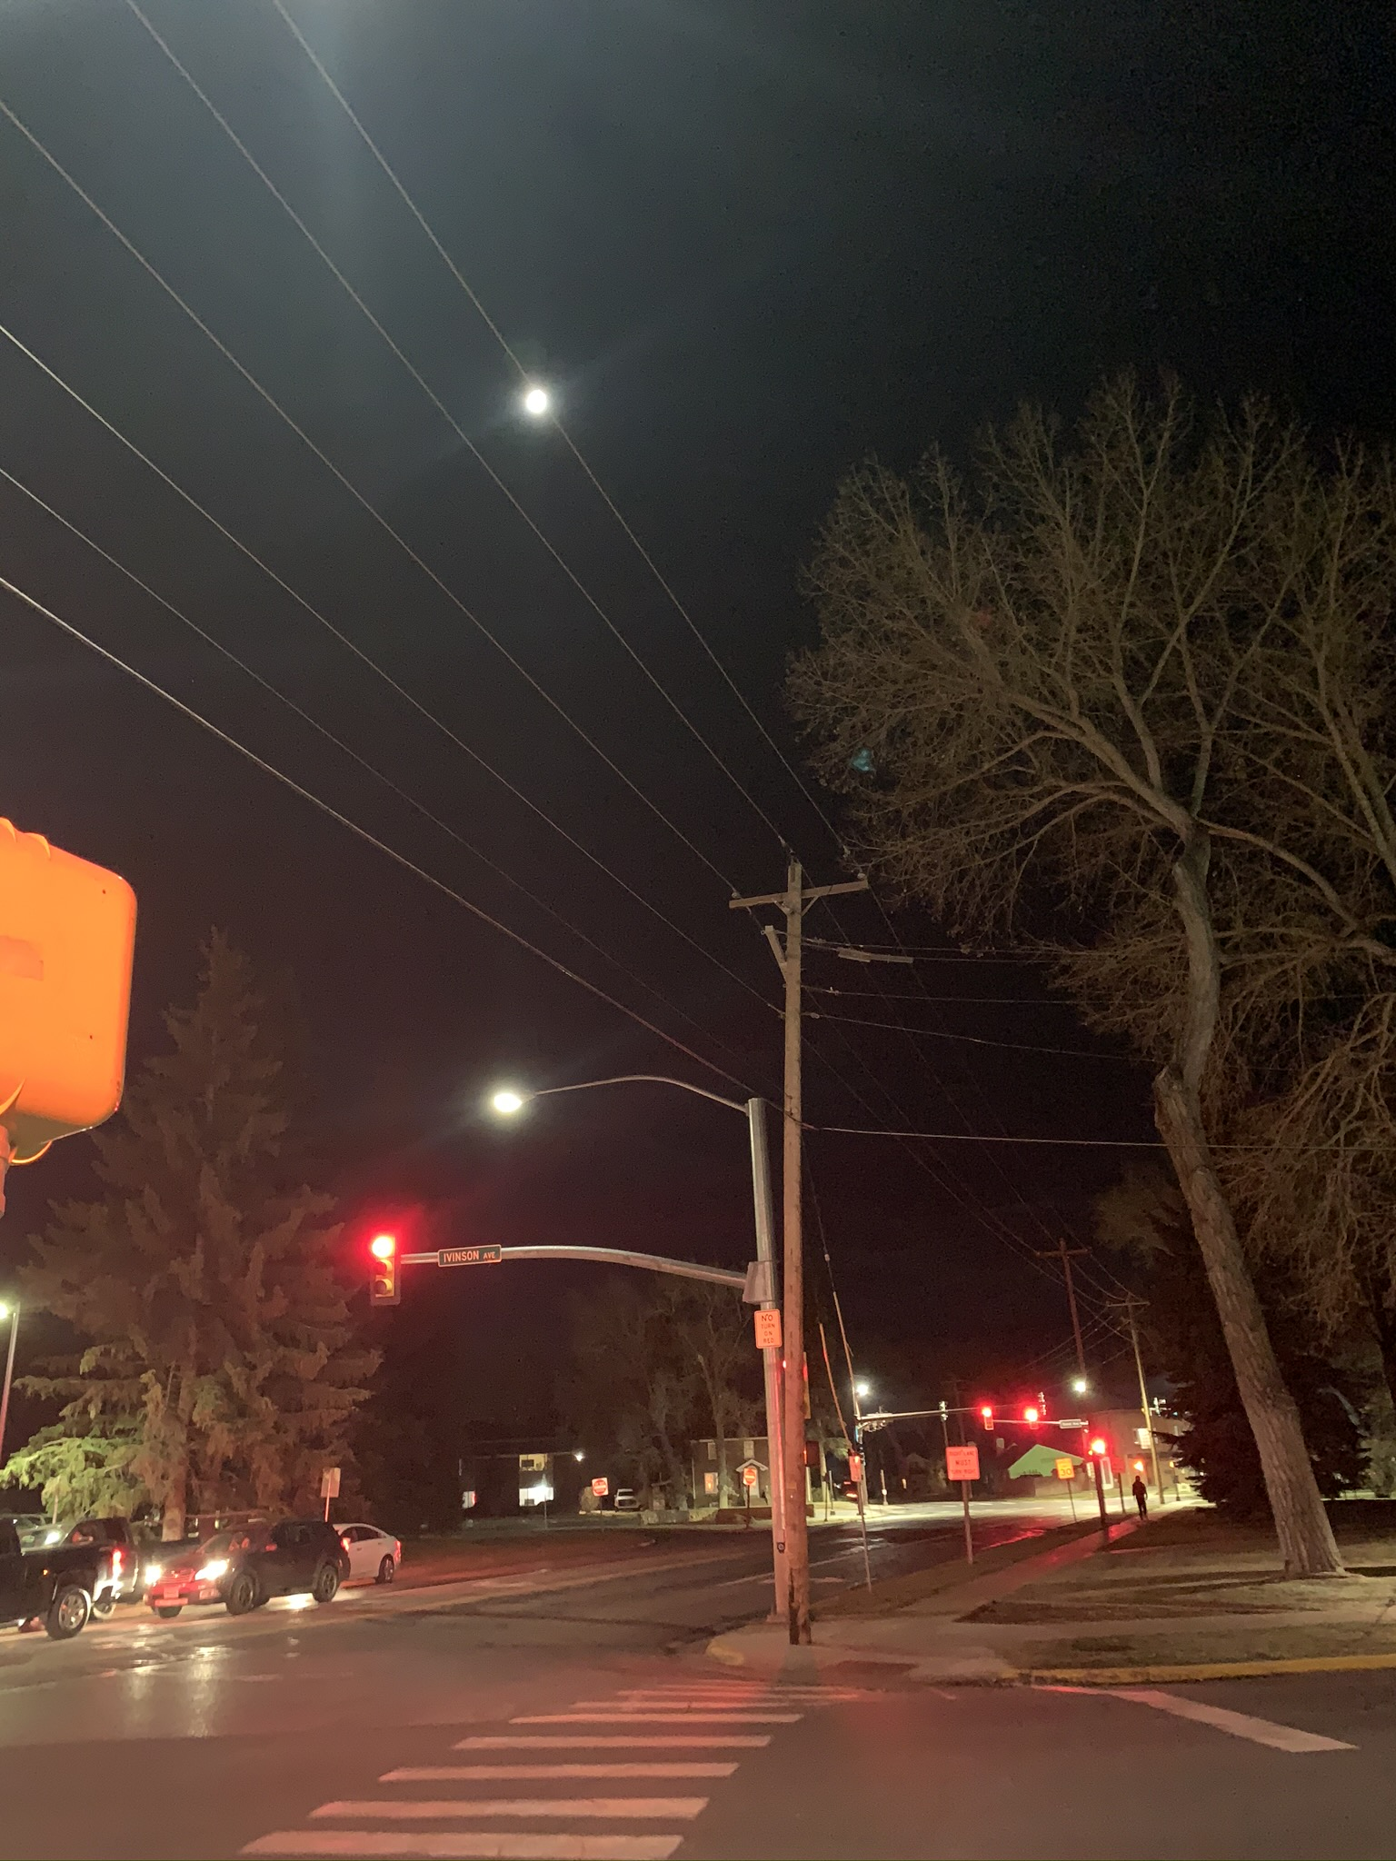

A

B

C

D

E

F

G

H

I

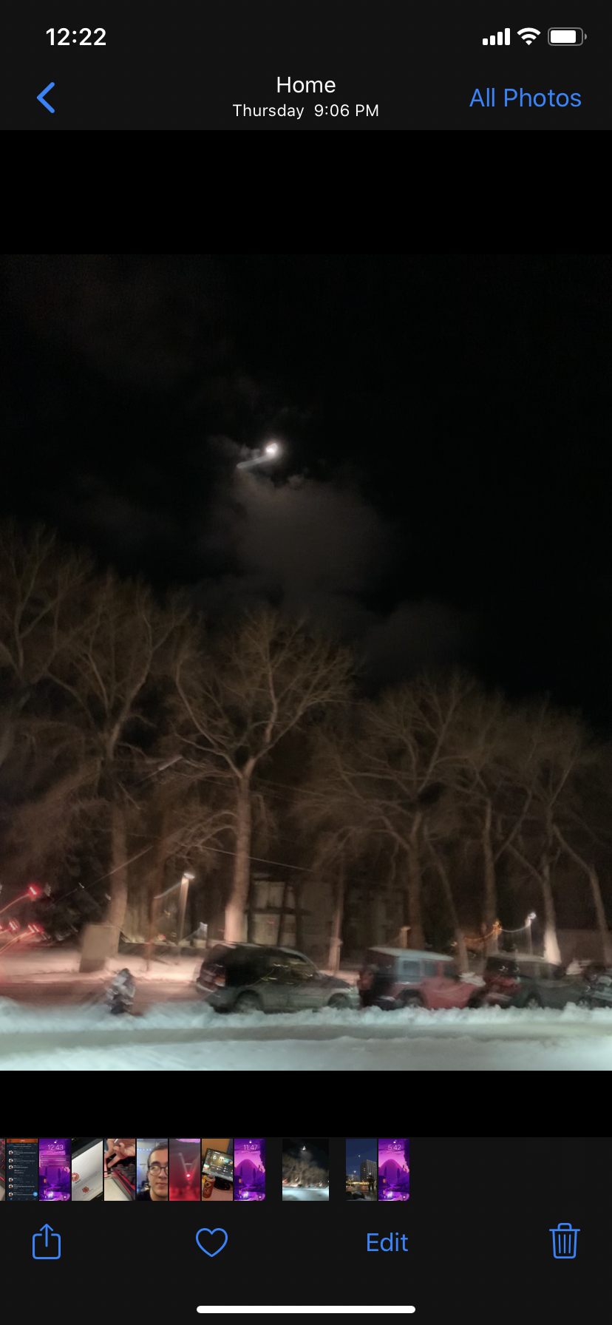

J

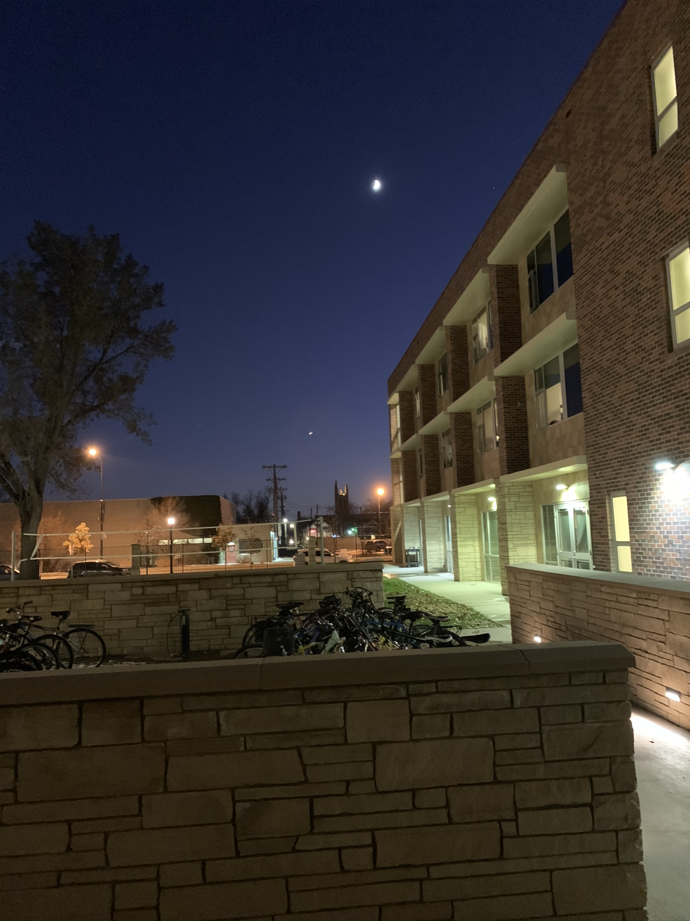

K

A: November 8, 2019; 8:07pm; Waxing Gibbous

B: November 9, 2019; 5:59pm; Waxing Gibbous

C: December 6, 2019; 5:07pm; Waxing Gibbbous

D: October 14, 2019; 9:03pm; Waning Gibbous

E: October 15, 2019; 10:18pm; Waning Gibbous

F: October 24, 2019; 9:11pm; Waxing Cresent

G: November 4, 2019; 5:08pm; First Quarter

H: November 5, 2019; 6:16pm; Waxing Gibbous

I: November 7, 2019; 9:04pm; Waxing Gibbous

J: December 5, 2019; 9:06pm; Waxing Gibbous

K: November 2, 2019; 6:37pm; Waxing Cresent

Throughout this experiment, it can be seen that the phases of the moon make a general cycle. They continually return to phases that they were at previously and make a constant return to previous phases. Throughout that continued cycle, we can infer the cycle time of the moon to make a full rotation, placing it at about 30 days. Furthermore, the shifting time required to take a photo with the moon in the same place means that we can demonstrably see that a single rotation about the Earth will take more than 24 hours to complete fully. As a result, we can confirm our understanding of the moon’s rotation about the Earth as it would be accurately modeled.